Case 7-AM,S-Peru-Moche-Mask-Jaguar Theriomorph-Copper-100 BCE-400 CE

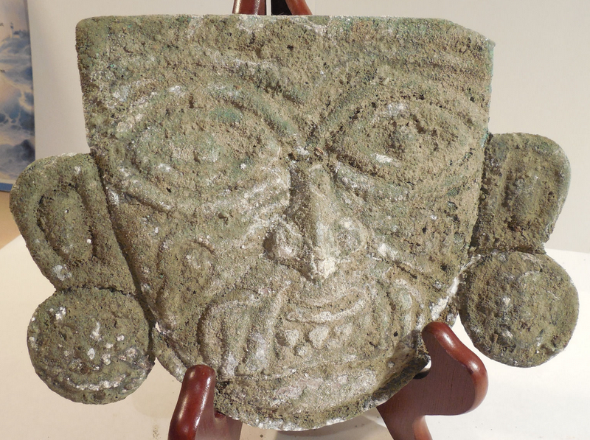

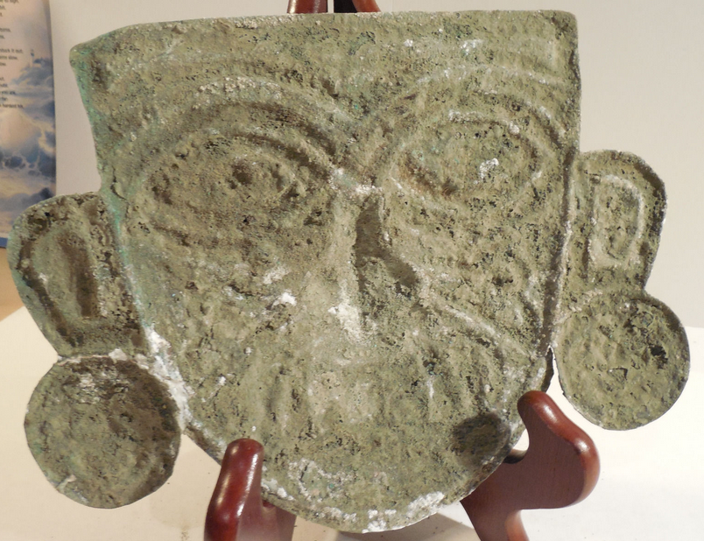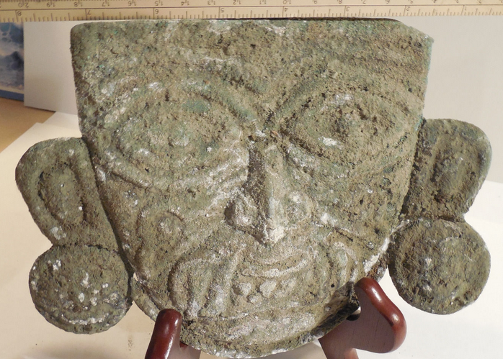

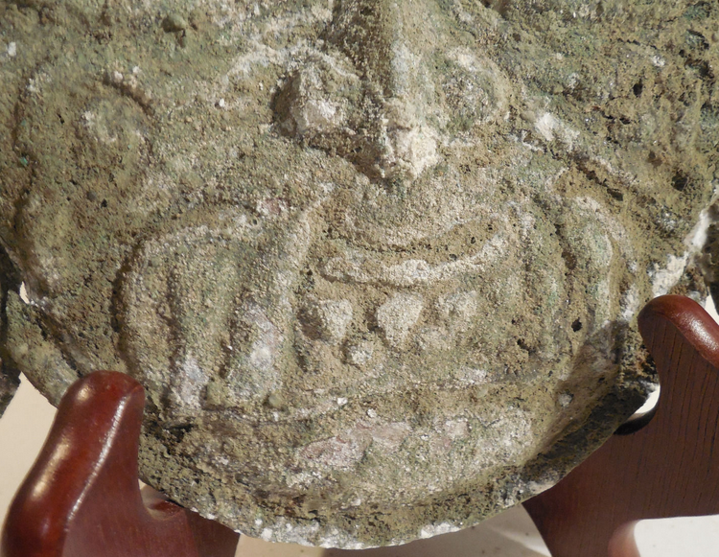 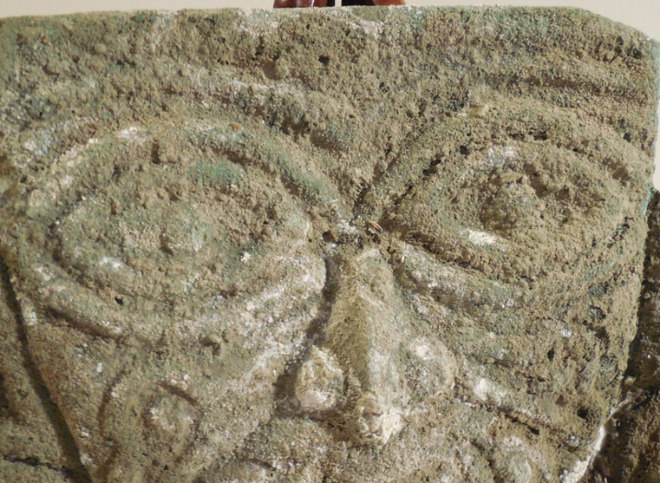

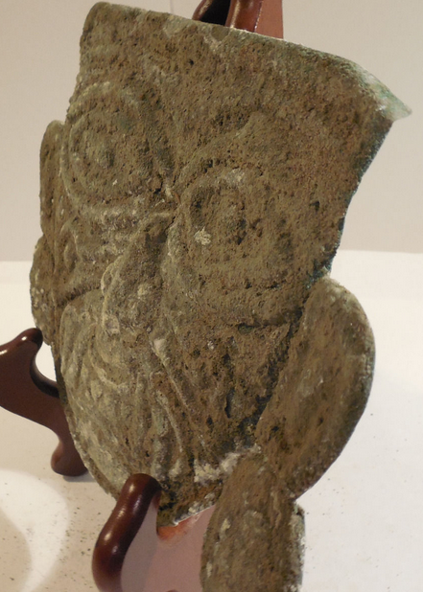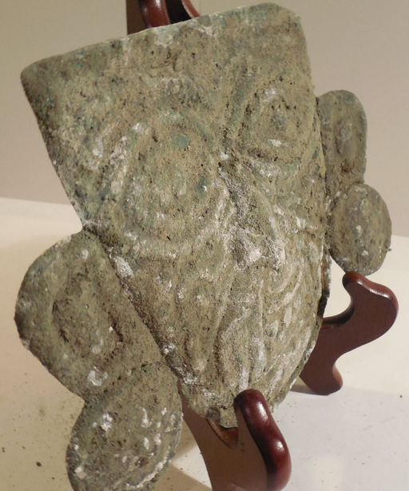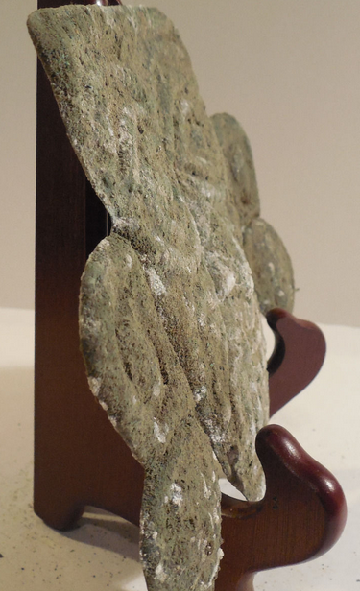

**Case no.: 7**

**Accession Number:**

**Formal Label: AM,S-Peru-Moche-Mask-Jaguar Theriomorph-Copper-**100 BCE-400 CE

**Display Description:**

A large copper mask of a shaman theriomorph of a jaguar spirit with jaguar fangs. He has almond-shaped eyes, a broad nose and fully shaped ears with ear spools.

**LC Classification: F3430.1.**

**Date or Time Horizon:** 100 BCE-400 CE

**Geographical Area:** N coastal Peru

**Map, GPS coordinates:**

**Appendix: AP 5.2**

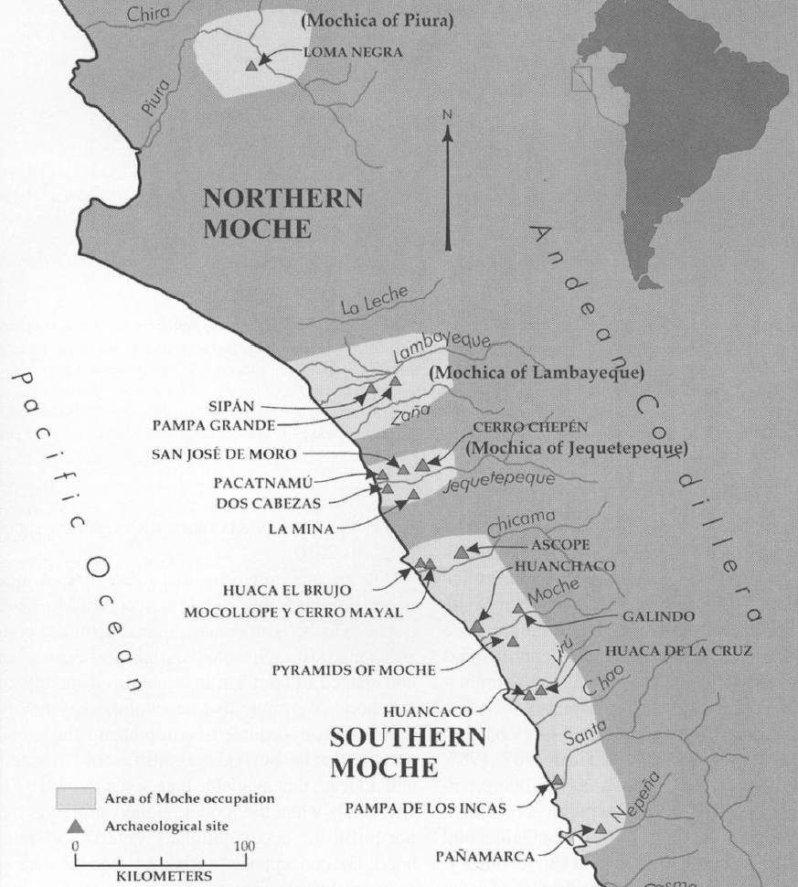

Fig. 6. Map of Moche regions as currently conceived and significant Moche sites. Map courtesy Moro Archaeological program.

**Cultural Affiliation:** Moche (Mochica)

**Medium:** Copper sheet with heavy encrusted verdigris patina. Ancient, cuprite and metallic sediment deposits yields a beautiful olive-green patina.

**Dimensions:** H 226.73 mm, 8.93 in;

**Weight:**

**Condition: Original.** Ancient, cuprite and metallic sediment deposits yields a beautiful olive-green to brown patina on reverse and olive-green on obverse.

**Provenance:** Ex. Arte Primitivo, Ex. Howard Nowes Gallery “Art for Eternity”.

**Discussion:** Jaguar maskettes were worn as pendants.

**References:**

Berezkin, Yuri. 1980. “An Identification of Anthropomorphic Mythological Personages in Moche Representations,” *Ñawpa Pacha,* 18:1-26.

Quilter, Jeffrey. 1990. “The Moche Revolt of the Objects,” *Latin American Antiquity,* 1:42-65.

Quilter, Jeffrey.1997. “The Narrative Approach to Moche Iconography,” *Latin American Antiquity,* 8:113-133.

Quilter, Jeffrey. 2002. “Moche Politics, Religion, and Warfare,” *Journal of World Prehistory,* 16:145-195.

Quilter, Jeffrey. 2008. “Art and Moche Martial Arts.” In *The Art and Archaeology of the Moche*, edited by Bourget, Steve and Kimberly L. Jones, pp. 215-228. Austin: University of Texas.

Quilter, Jeffrey. 2010. *Moche: Media and Messages*. Cambridge: Peabody Museum Press, Harvard University.

Quilter, Jeffrey, and Luis Jaime Castillo Butters (editors) 2010. *New Perspectives on Moche Political Organization*. Cambridge: Dumbarton Oaks.

Quilter, Jeffrey, and Michele L. Koons, M. 2012. “The fall the Moche: a critique of claims for South America’s first state,” *Latin American Antiquity*, 23(2), 127-143.